**INTERNSHIP REPORT**

**ON**

**CNERGYIS INFOTECH PVT LTD**

**[ZINGHR]**

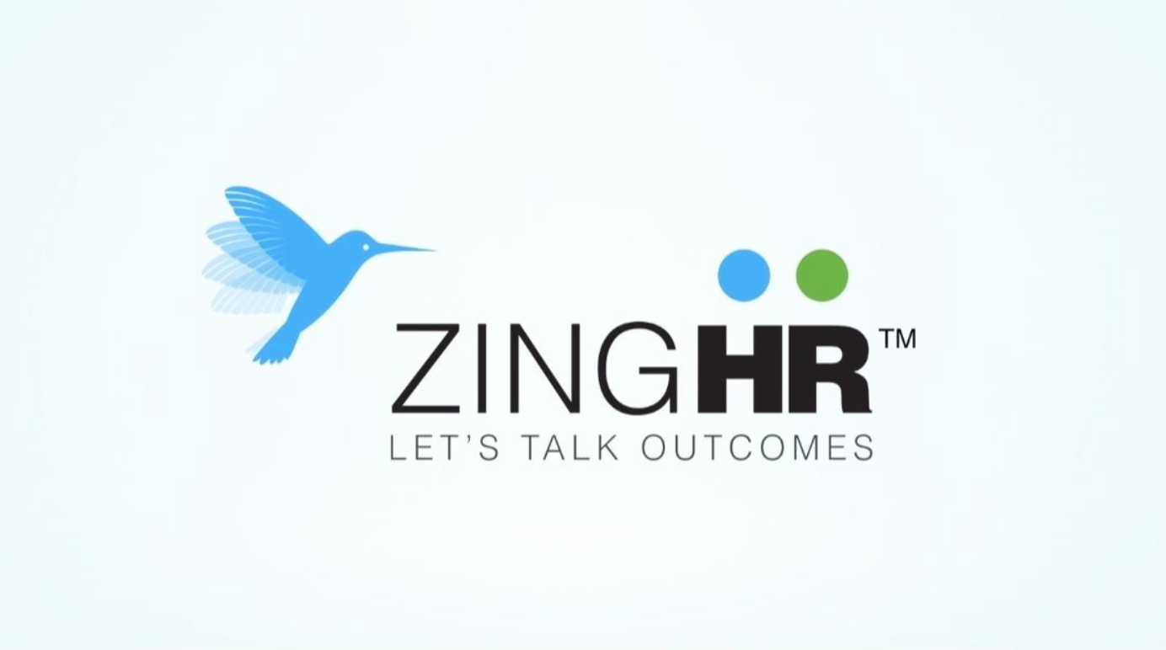

NAME: YASHWANTH.R

SID: 20241CCS3001

PROGRAM: B.TECH CSE (CYBERSECURITY)

DURATION: 1 JULY 2025 – 31 JULY 2025

SUBMISSION ON : 11 AUGUST 2025

**Acknowledgement**

I'd like to express my sincere gratitude to everyone who supported me throughout my internship and the writing of this report.

First, a special thank you to my internship supervisor, ADITYA MULEY , for their guidance, mentorship, and invaluable insights. Their expertise and trust in my abilities were instrumental to my success.

I am also thankful for the support of the entire team at ZINGHR. The collaborative and welcoming environment made my experience incredibly rewarding.

Finally, I would like to thank my university advisor’s for their continuous encouragement and support, which helped me connect my practical experience with my academic studies.

**INDEX**

**1. Executive Summary 4**

**2. Introduction 6**

**3. Company Overview: ZINGHR 8**

**4. Learning Outcomes and**

**Self-Evaluation 11**

**5. Conclusion 15**

**Executive Summary**

**The Purpose of the Internship:**

This internship report provides a comprehensive overview of my one-month experience at ZINGHR, fulfilling the practical training requirement for my B.TECH program at PRESIDENCY UNIVERSITY.

**A Brief Overview of the Company:**

ZingHR is a global human capital management (HCM) solutions provider. Based in Mumbai, India, the company specializes in offering a comprehensive, cloud-based platform that manages the entire "Hire to Rehire" employee lifecycle. Their mission is to help organizations transition from a traditional "Total Cost of Ownership" mindset to a focus on "Tangible Business Outcomes."

**Key Skills Developed and Lessons Learned:**

Through my work, I developed proficiency in **Penetration Testing** , enhanced my professional communication and project management skills, and gained a deeper understanding of **Penetration Testing in web security**

**Overall Conclusion:**

In conclusion, the internship was an invaluable experience that not only allowed me to apply my academic knowledge in a real-world setting but also solidified my career aspirations in the cyber security industry. The skills and insights I gained have prepared me for my future professional endeavors.

**Introduction**

This internship report details my experience at **ZingHR** from 1-july-2025 to 31-july-2025, as a required component of my B.TECH program at presidency university. The primary purpose of this document is to provide a comprehensive summary of my professional development, the tasks I performed, and the skills I acquired while working in a real-world corporate environment. It serves as a bridge between the theoretical knowledge I have gained in academia and its practical application.

During my time at the company, I was placed in the **Product Development** department. ZingHR, a leading global human capital management (HCM) solutions provider, is dedicated to offering a full suite of cloud-based HR solutions that optimize the entire employee lifecycle. My time in the Product Development department provided me with a unique opportunity to understand how these technological solutions are developed, marketed, and supported in a highly competitive industry.

The key objectives I aimed to achieve during this internship were to:

* **Apply academic knowledge:** Translate the theoretical concepts learned in my coursework, particularly in security assessment and testing to practical, real-world scenarios.
* **Develop professional skills:** Enhance my communication, teamwork, and problem-solving skills in a professional setting.
* **Gain industry-specific insights:** Understand the latest trends, challenges, and innovations within the HR technology sector.
* **Contribute meaningfully:** Participate in projects that provided value to the company and allowed me to make a tangible contribution to the team's goals.

**Company Overview: ZINGHR**

This section provides a detailed description of ZingHR, the company where I completed my internship. It outlines the company's background, its strategic focus, and its position within the competitive human capital management (HCM) industry.

**History and Founding**

ZingHR was founded in **2014** by a team of co-founders, including Prasad Rajappan, Ravi Bajaj, and Venkat Balan. However, its roots trace back to an HR consulting organization called Cnergyis, founded in 2006. The founders' vision was to create a cloud-based platform that would manage the entire employee lifecycle, from **"Hire to Rehire,"** moving beyond simple HR automation to focusing on tangible business outcomes. The company is headquartered in Mumbai, India, and has since grown into a global enterprise with a significant presence across various industries.

**Vision, Mission, and Core Values**

ZingHR's strategic approach is centered on a concept they call **"Outcomation,"** which is a blend of automation and delivering tangible business outcomes.

* **Vision:** To be at the forefront of HR innovation by leveraging emerging technologies like AI, blockchain, and machine learning to drive business outcomes and transform HR processes.
* **Mission:** To help enterprises transition from a traditional "Total Cost of Ownership" (TCO) model to a focus on "Tangible Business Outcomes" (TBO) through their technology platform.
* **Core Values:** While not explicitly listed in a single statement, ZingHR's values are demonstrated through its commitment to innovation, customer satisfaction, and a belief in the power of technology to improve the "People, Profit, and Planet" of an organization. This is reflected in their emphasis on user-friendly, mobile-first solutions and a dedication to corporate social responsibility.

**Products and Services**

ZingHR offers a comprehensive suite of cloud-based HCM solutions. These services are modular, allowing businesses to select and pay for only the functionalities they need. The key product areas include:

* **Workforce Management:** Tools for time and attendance tracking, shift rostering, leave management, and employee self-service. The platform utilizes advanced technology like facial recognition for accurate attendance.
* **Talent Acquisition and Management:** Features for end-to-end recruitment, digital onboarding, performance management (including OKRs and KPIs), and succession planning.
* **Payroll and Compliance:** Automated payroll processing, statutory compliance management (e.g., PF, ESI, TDS), and full and final settlement, with a focus on a "Zero-Touch Payroll" system.
* **Employee Engagement:** AI-powered modules and surveys to boost employee morale and well-being, fostering a more connected and collaborative workplace.
* **Learning and Development (L&D):** Integrated learning management systems (LMS) to facilitate training, career planning, and upskilling for employees.

**Market Position and Organizational Structure**

ZingHR holds a competitive position in the HR technology market, especially within the Asia-Pacific region. It's recognized for its agility and innovative approach, often being cited as a leader in the mid-market segment and a strong competitor to larger, more traditional HCM platforms. The company has a global presence with over 1,200 customers and millions of users worldwide.

**Learning Outcomes and Self-Evaluation**

This section critically analyzes my internship experience, moving beyond a simple list of tasks to reflect on the knowledge and skills I gained, how they connect with my academic background, and the impact they've had on my personal and professional development.

**1. Skills Developed**

My role as a **Penetration Testing intern** within the Product Development Team at ZingHR provided me with a unique opportunity to enhance a variety of technical and soft skills.

* **Technical Skills:** I gained hands-on experience with industry-standard penetration testing tools and methodologies. I became proficient in using tools like **Burp Suite** for web application security testing, **Nmap** for network scanning, and **Metasploit** for vulnerability exploitation. I learned to identify and exploit common web vulnerabilities such as SQL Injection, Cross-Site Scripting (XSS), and Broken Authentication. Furthermore, I developed my report-writing skills, learning to document vulnerabilities and provide clear, actionable recommendations for remediation.
* **Professional Skills:** Working within a product development team gave me insight into the software development lifecycle from a security perspective. I learned to collaborate with developers and quality assurance (QA) teams, providing constructive feedback and helping to integrate security best practices early in the development process. This experience significantly improved my **teamwork and communication skills**, particularly in explaining complex technical issues to non-security experts.
* **Soft Skills:** The fast-paced environment required me to be highly adaptable and resourceful. I honed my **problem-solving skills** by tackling complex security challenges and thinking creatively to find new vulnerabilities. My ability to manage time effectively and prioritize tasks was also significantly enhanced as I juggled multiple testing projects simultaneously.

**2. Connection to Academics**

The internship served as a vital bridge between my university coursework and its real-world application. The theoretical knowledge I gained in my **Cyber Security** and **Network Security** classes became the foundation for my practical work.

* Concepts from my **"Ethical Hacking"** course, such as the reconnaissance and scanning phases of a penetration test, were directly applied to my work at ZingHR. I was able to use the principles of vulnerability analysis and exploitation that I had only studied in a controlled lab environment.
* My understanding of different **network protocols (TCP/IP)** and **web application architecture** from my networking courses was crucial for navigating the company's infrastructure and identifying potential security flaws. This experience not only reinforced what I had learned but also provided a deeper, more nuanced understanding of how these systems function in a production environment.

**3. Personal and Professional Growth**

This internship has been a transformative experience, shaping both my immediate professional trajectory and my long-term career goals.

* **Career Goals:** The practical experience of a penetration tester has solidified my passion for offensive security. I now have a clearer understanding of the day-to-day responsibilities and challenges of the role, which has confirmed my desire to pursue a career in this field. I am more confident in my ability to contribute to an organization's security posture.
* **Professional Development:** The internship provided me with invaluable exposure to a professional work environment. I learned the importance of continuous learning and staying updated on the latest security threats and tools. The experience also highlighted the critical role of security in the product development lifecycle, instilling in me the importance of a security-first mindset.

In conclusion, my internship at ZingHR was not just about performing tasks, but about a comprehensive process of learning, application, and self-discovery. It has equipped me with a robust skill set and a clear direction for my future career in cybersecurity.

**Conclusion**

My internship as a Penetration Testing Intern at ZingHR was a profound and formative experience that successfully bridged the gap between academic theory and professional practice. Over the course of my time with the Product Development team, I was able to apply, test, and deepen my knowledge of cybersecurity in a real-world, dynamic environment. This report has detailed how the opportunity provided an invaluable platform for me to grow both professionally and personally.

The objectives I outlined at the beginning of this journey were met with great success. I was not only able to contribute to the security posture of ZingHR's HCM platform but also to hone a diverse set of skills. On the technical front, I gained hands-on expertise with industry-standard tools like **Burp Suite** and **Nmap**, identifying and reporting critical vulnerabilities that could have impacted the company's applications. My understanding of the common attack vectors, such as SQL Injection and XSS, moved from a conceptual level to a practical, hands-on ability. More importantly, I learned the professional discipline required for ethical hacking—meticulous documentation, clear communication of findings to technical and non-technical stakeholders, and the collaborative process of working with developers to ensure timely and effective remediation.

This experience directly reinforced the concepts and theories I have been studying in my university courses. My foundational knowledge of ethical hacking, network protocols, and secure coding practices was put to the test every day. It was incredibly rewarding to see the principles discussed in lectures and labs come to life, confirming the relevance and importance of my academic curriculum. The internship served as a powerful validation of my educational path and a motivation to delve even deeper into the field.

Beyond the technical skills and academic connections, the internship profoundly influenced my professional development. It has solidified my passion for a career in offensive security and provided me with a clear understanding of the career path ahead. The opportunity to work in a corporate setting also improved my soft skills, such as time management, critical problem-solving, and adaptability. I learned the importance of taking initiative, asking questions, and continuously seeking to expand my knowledge in an ever-evolving field.

In summary, my internship at ZingHR was an exceptional opportunity for growth. It provided me with a strong foundation in practical cybersecurity, a clearer vision for my career, and the confidence to take on future professional challenges. I am grateful for the guidance and support of my colleagues and mentors at ZingHR, and I am confident that the skills and insights I gained will be instrumental in my continued journey as a cybersecurity professional.